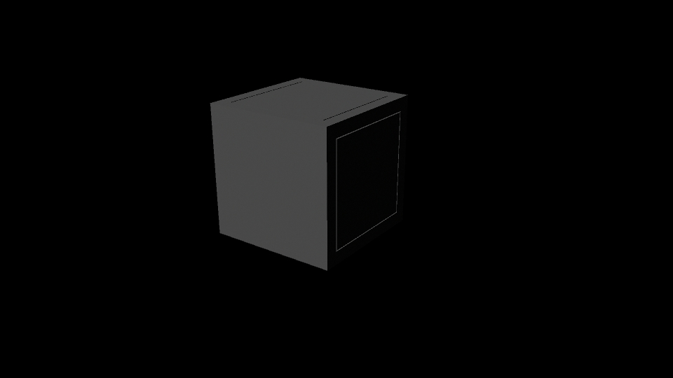

The cube was modelled using very simple geometry, this was done to save on polys and to make sure there was as little complications as possible when it came to movement.

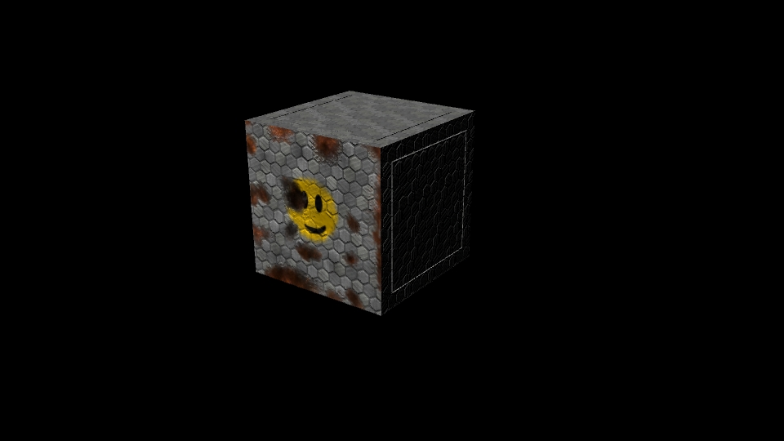

The box was then textured using a simple “futuristic” metal look in photoshop with a rust layer underneath it. The eraser tool was then used to remove parts of the metal layer to give the illusion of the metal beginning to rust.

A bump map and specular map were used to give the illusion of depth within the texture of the metal and rust.

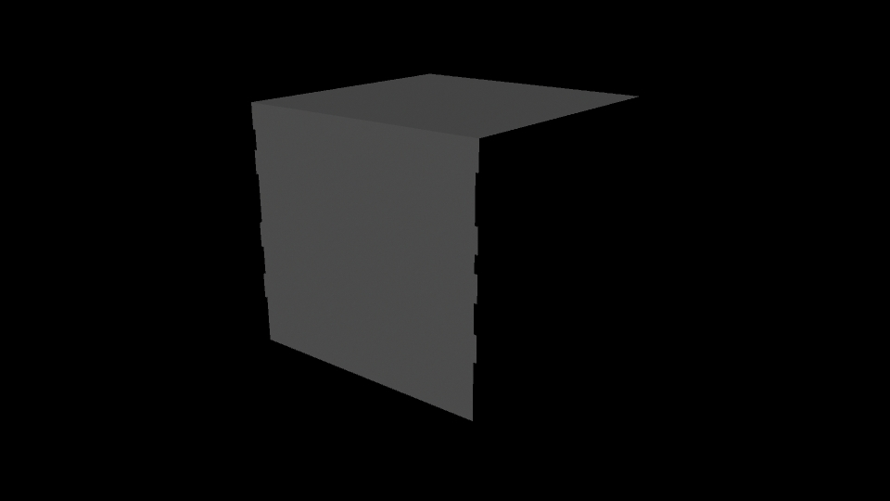

The metal box model again was made to be as geometrically simple as possible as to save on polys.  
The sides, back and bottom of the box were removed as the game is in an orthographic view and would not be seen and this again would save on polys.

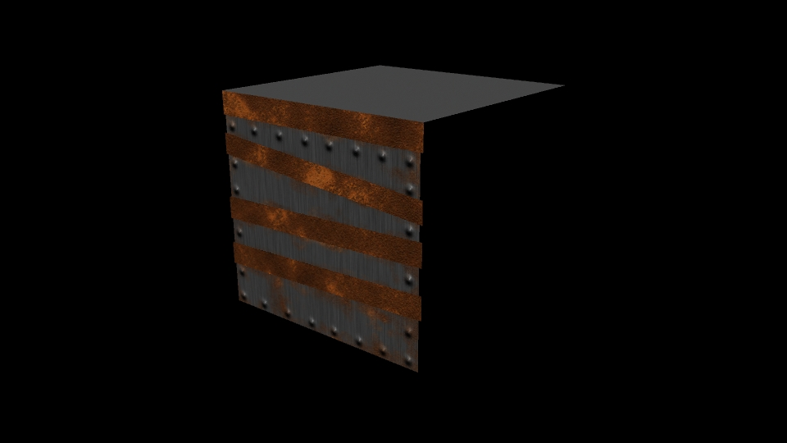

The texture was then created in the same way as the cube using a top level steel texture with a rust texture underneath and the eraser tool used to remove parts of the steel texture.

A bump map and specular map was used to create the illusion of rivets within the metal.

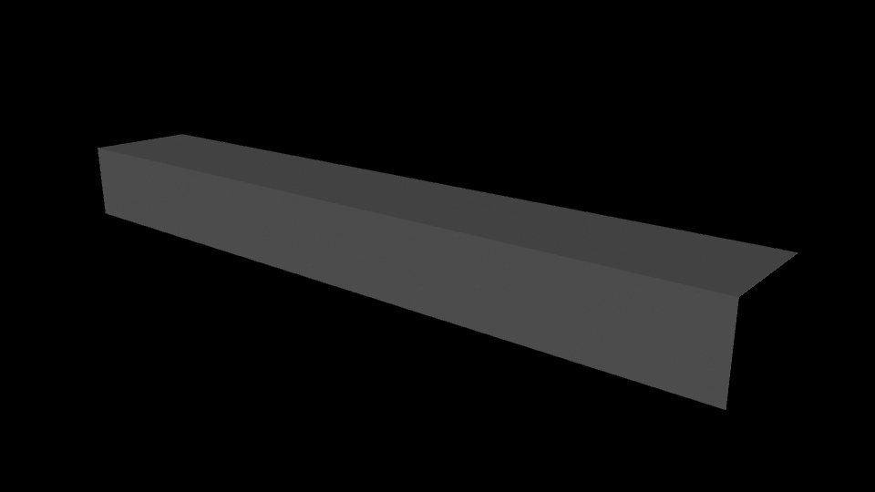

The concrete floor model was created in the same way as the metal box texture with the sides, bottom and back removed to save on polys.

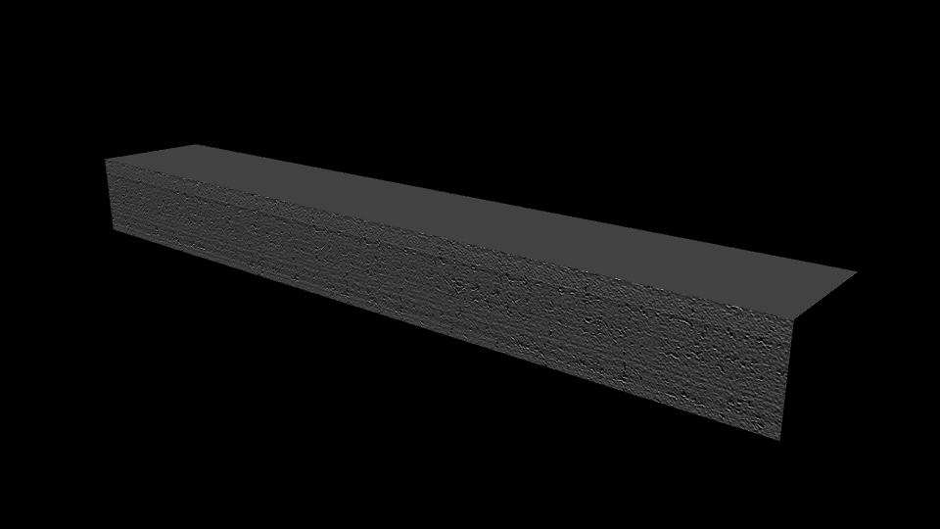

A flat concrete texture was created in photoshop and applied. A bump map and a specular map again were used to give the illusion of depth while saving on polys.

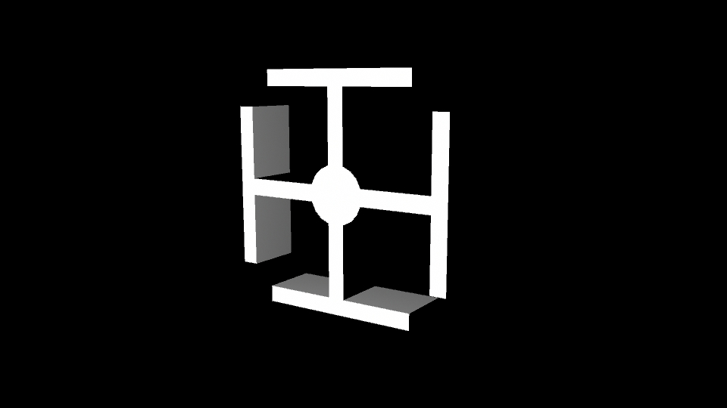

The rotating platform was modelled by creating a cylinder with 16 sides and then extruding 2 polys from each 90 degree angle.  
The back of the model was removed to save on poly space but the tops, bottoms and sides of the pieces were left just in case of lighting reflection issues.

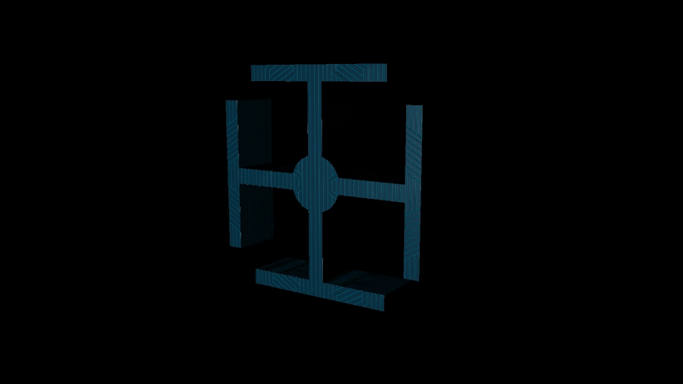

The texture was created in Photoshop using a series of “futuristic” looking straight lines.

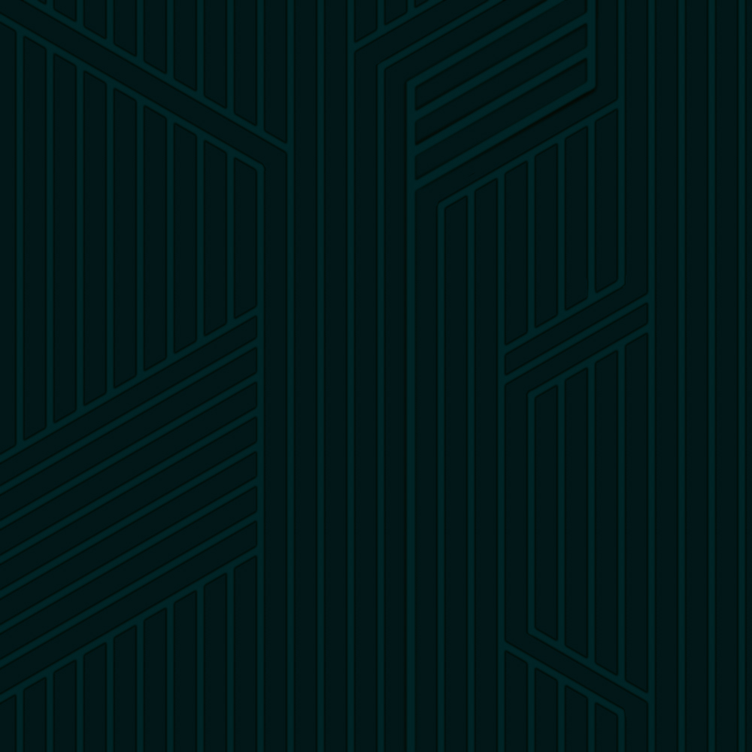

The texture was then re-coloured until it achieved a hue that fit the theme and looked nice, this ended up being a cold blue.

A bump map and texture map were then used to give the illusion that the lines were indented into the metal.

The game uses a custom-made dust particle texture that contains a mix of gray and white colors to the feel of depth between each particle.

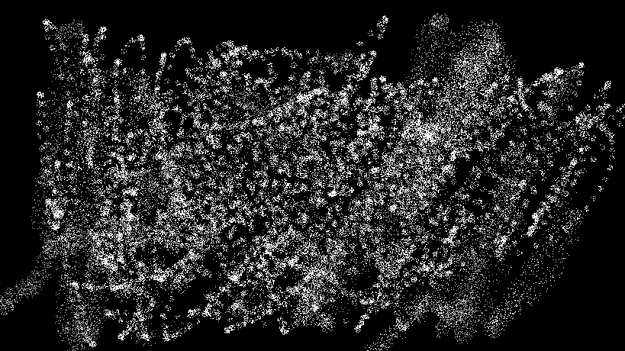

In-game screenshots:

